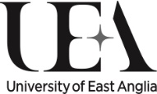

2024 begins a 6-month investigation at the Sainsbury Centre

WHAT IS TRUTH?

This year, the Sainsbury Centre will investigate how we can know what is true in the world around us through a series of fascinating, interlinked exhibitions.

Against the backdrop of fake news, elaborate scams and the burgeoning presence of Artificial Intelligence, the international museum in Norwich will ponder whether we are experiencing a time when increasingly sophisticated technology can distort reality and diminish our own sense of authenticity.

The dynamic 2024 programme consists of four key, interlinked exhibitions – In Event of Moon Disaster, Liquid Gender, Jeffrey Gibson: no simple word for time and The Camera Never Lies – bringing together some of the world’s leading artists and creative thinkers, plus a new, interlinking publication.

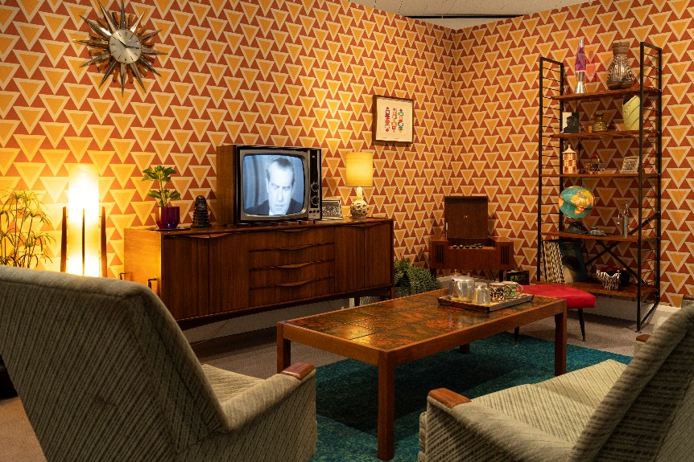
In Event of Moon Disaster
17 February – 4 August 2024

The programme kicks off with an Emmy Award-winning interactive experience that is a deep dive into misinformation and conspiracy. Using AI to tell an alternative history, the show brings to light how an event as influential as the 1969 Apollo 11 moon landing could be manipulated, and how doubt can be cast on even the most well-known of facts.

Despite the United States´s space race rival at the time not even raising any doubts, a YouGov poll from 2019 found 16% of the British public believe the moon landing most likely never happened.

It remains one of the most famous conspiracy theories in the world, and one aspect that has been caught up in the theory is a prepared speech by President Nixon that was to be given in case the mission ended in catastrophic failure. The speech, titled ‘In event of moon disaster’, was of course never delivered, but now visitors to the Sainsbury Centre will be able to experience it like never before.
American new media artist Halsey Burgund (b.1973) and British digital artist Francesca Panetta (b.1977) have reconstructed the speech with the use of state-of-the-art deepfake technology. Played back on a vintage television like the ones that carried the moon-landing broadcast to 1960s living rooms around the world, the installation will highlight the media that are used to either build or destroy trust.
Both artists draw on their expertise in technology and creative fields, with Burgund being Creative Technologist-in-Residence at the MIT Open Documentary Lab and Panetta as Director of the Storytelling Institute at the University of the Arts, London.
The artists said: “By using the most advanced techniques available, creating a video using both synthetic visuals and synthetic audio (a “complete deepfake”), we aim to show where this technology is heading – and what some of the key consequences might be.”
In Event of Moon Disaster is an MIT Center for Advanced Virtuality production. The work won an Emmy Award for Interactive Media Documentary in 2021.

Liquid Gender
17 February – 4 August 2024
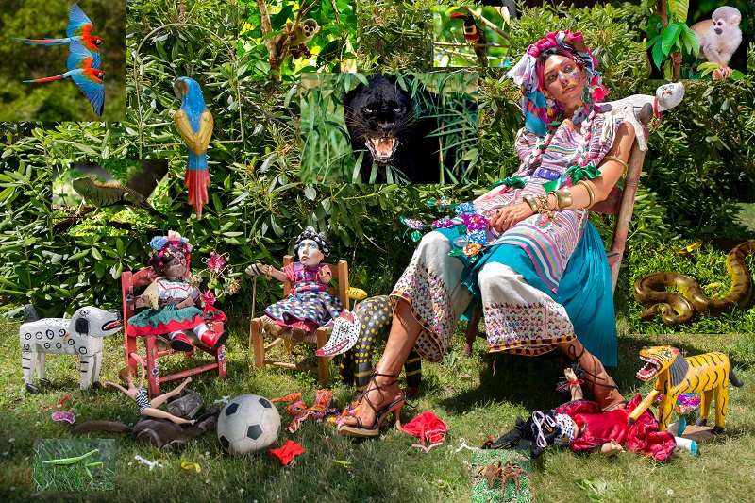
In an exploration of the relationship between gender expression and identity, with a focus on pre-colonial traditions, the Sainsbury Centre will present works by a myriad of internationally acclaimed artists, including new work, UK premieres and new acquisitions.
New Orleans born Rashaad Newsome (b.1979), whose multi-disciplinary work explores black and queer space in art history, will make a new holographic work titled In the Absence of Evidence, We Create Stories (2024) which will look both to the cultural traditions of the past and the possibility of the future. Using objects from the Sainsbury Centre´s own collection, these will be used as part of a visual dialogue with African sculptures that transform into futuristic cyborgs and speak about their past, present and future.
In a UK premiere, American artist Martine Gutierrez (b.1989) will showcase her Demons (2018) series in its entirety which depicts the artist as a deity from Aztec, Maya and Yorùbá traditions. Part of her ‘Indigenous Woman’ publication, a 146-page art magazine inspired by glossy magazines, the images are infused with androgynous characteristics.
Afro-indigenous photographer Laryssa Machada (b.1993) and Indigenous creative Antônio Vital Neto Pankararu document queer Indigenous identities in the Brazilian Northeast in Origem (2020), a series of photographic portraits overlaid with Indigenous motifs accessible through an augmented reality (AR) application designed by pioneering Bolivian digital artist Lucia Grossberger Morales (b. 1952). The result of a research project at the University of Leeds, it draws on centuries of both visibility and oppression of queer people in Brazil.

When artist Leilah Babirye (b.1985) sought asylum in the US after being publicly outed in her native Uganda, she saw drag queens for the first time, which inspired a series of vibrant works on paper. A group of these titled Kuchu Ndagamuntu (Queer Identity Card) (2021), which depicts the many faces and identities of her ambiguously gendered subjects will be presented. One of these works has also now been acquired by the Sainsbury Centre – thanks to funding from the Art Fund’s New Collecting Award - and will join the permanent collection.

Jeffrey Gibson: no simple word for time
24 February - 4 August 2024

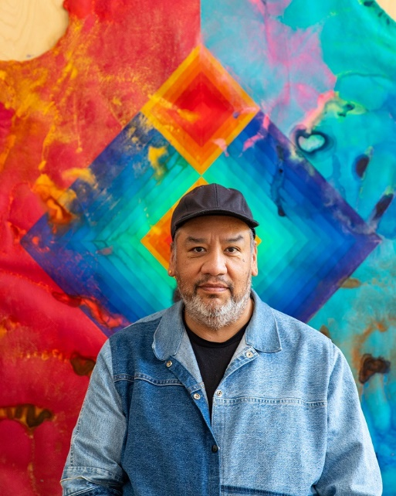
In his first solo exhibition at a UK museum, American artist Jeffrey Gibson (b.1972) will create a new site-specific installation for the Sainsbury Centre.
The first Indigenous artist to represent the USA at this year´s Venice Biennale, Gibson is a painter and sculptor whose work is held in many major American collections. Incorporating murals, paintings, textiles and historical objects, Gibson’s work also weaves together text drawn lyrics, poetry and his own writing, complete with references to abstraction, fashion and popular culture.
Of Mississippi Choctaw and Cherokee heritage, Gibson uses materials such as Native American beadwork and trading posts in his art that explores identity and labels.
Now, Gibson will create a vast installation that incorporates 19th and 20th century objects from Indigenous cultures across North America. Alongside the beadwork, parfleche and dolls that are common motifs in Gibson´s work, I can choose (2024) will consider the artist´s relationship with these items alongside how they are displayed within public facing museums.
The exhibition will illuminate the rich practice of abstraction in Indigenous art, going against the common narrative within UK museums that abstraction only emerged in the 20th century. It continues a specific focus on this area of art from the Sainsbury Centre, following last year´s successful exhibition Empowering Art: Indigenous Creativity and Activism from North America’s Northwest Coast.
Jeffrey Gibson: no simple word for time is supported by Stephen Friedman Gallery.

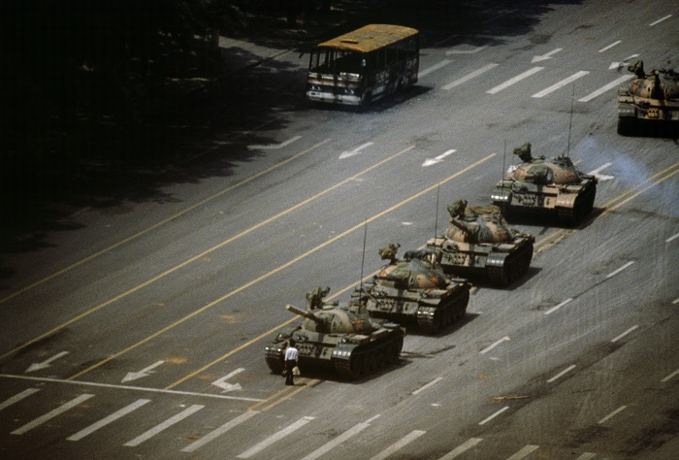
The Camera Never Lies: Challenging images through The Incite Project
18 May – 20 October 2024
Re-evaluating some of the most iconic images of the past 100 years will be an exhibition dedicated to the impact and influence photography has had on shaping – and in some cases misdirecting – the narrative of major global events.
Featuring more than 80 works by photographers such as Don McCullin (b.1935), Stuart Franklin (b.1956) and Robert Capa (1913-1954), the exhibition will chart a global century of documentation and manipulation, through fact and fiction.
Sometimes seen as superior to text, photographs are now a mainstay of how the media and the public consume events such as war, famine, and celebrity.
Sir Donald McCullin CBE is perhaps one of the most famous war photographers of the 20th century and his images have charted conflicts as well as the seemingly ´downtrodden´ in society. The British photographer eschews colour photography in favour of black and white images and has reported from varied places such as Vietnam, Cambodia, Lebanon, the Congo and Northern Ireland.
The power of McCullin´s images have also been feared by Governments, and after being refused a press pass to document the Falklands War, rumours still abound whether this was an administrative error or a deliberate action by the Government who were concerned with the distressing reality that McCullin´s lens could reveal.
Photographs from McCullin´s time in Vietnam will be included in the exhibition, showing visitors how some of the most famous war images of the time can be interpreted.
Another influential conflict photographer is Robert Capa and his renowned Death of a Loyalist Solider, Cordoba Front, Spain (1936) will also be included. The Hungarian American had been caught up in the tumultuous events of Europe at the start of the century, first fleeing his homeland to Berlin where he then witnessed the rise of the Nazis. Amongst the danger, Robert Capa documented the Spanish Civil War with Ernest Hemingway, and then became the only civilian photographer to land on Omaha beach during D-Day in June 1944. Eventually his work took him to Vietnam, where he died after stepping on a landmine.
21st century photography which reflects on the relationship between the camera and truth will also be investigated, and the people who are shining a light on the marginalised and overlooked. Including themes such as Government surveillance, domestic violence, and the effect of conflict on civilian populations, the exhibition will include work by Edmund Clark, Simon Norfolk, Trevor Paglen and Max Pinckers.
Curated by Harriet Logan and Tristan Lund, the works in this exhibition are drawn from The Incite Project, a private collection of photojournalism, documentary photography and photographic art with a remit to support contemporary practitioners.

What is Truth?
New publication from February 2024
Accompanying this season will be a new book, What is Truth? exploring the question of truth in art history, photography, museums and art in a post-truth world.

It will include new essays by academics and curators Frances Borzello, Paul Luckraft, Tania Moore and Pelumi Odubanjo, alongside conversations exploring these questions with The Incite Project’s Harriet Logan and Tristan Lund, as well as artists Jeffrey Gibson and Rashaad Newsome.

What is Truth? is edited by Tania Moore and published by the Sainsbury Centre.

VIDEO
Watch the Director’s Introduction to the Sainsbury Centre’s What Is Truth? season here

NOTES TO EDITORS
HIGH RESOLUTION IMAGES FOR MEDIA USE CAN BE DOWNLOADED HERE
- In Event of Moon Disaster at the Sainsbury Centre. Copyright: Halsey Burgund and Francesca Panetta. Photo: Kate Wolstenholme
- Martine Gutierrez, Queer Rage, Imagine Life-Size, and I'm Tyra, p66-67 from Indigenous Woman, 2018. © Martine Gutierrez; Courtesy of the artist and RYAN LEE Gallery, New York
- Jeffrey Gibson. Photo: Brian Barlow. Courtesy of Jeffrey Gibson Studio
- Stuart Franklin The Tank Man stopping the column of T59 tanks. Tiananmen Square, Beijing, China. 4th June 1989. © Stuart Franklin/Magnum Photos

The Sainsbury Centre is a world class art museum with a unique perspective on how art can foster cultural dialogue and exchange. Following a radical relaunch in 2023 it is the first museum in the world to formally recognise the living lifeforce of art, enabling people to build relationships across an arts landscape.
The art of the Sainsbury Centre is able to help reframe and answer the most important questions people have in their lives. It is not a museum to only learn more about artists, cultures or movements like Francis Bacon, the Tang Dynasty or Modernism, it is a place of experience, where collections are animate and visitors are emotionally connected.
One of the first museums in the world to display art from all around the globe and from all time periods equally and collectively, Sir Robert and Lady Lisa Sainsbury created one of the most sought after yet non-conformist art collections.
In 1973 they donated their collection, which transcended traditional barriers between art, architecture, archaeology and anthropology, to the UEA, and created an entirely new type of museum. Housed in Sir Norman Foster’s revolutionary first ever public building, the space aimed for an interactive relationship between people, object and landscape, where art was placed within an open yet intimate ‘living area’.

Visit www.sainsburycentre.ac.uk
Follow @sainsburycentre on Facebook, Twitter and Instagram

FOR MORE INFORMATION, INTERVIEWS AND IMAGES

Kate Wolstenholme
Press officer at the Sainsbury Centre

k.wolstenholme@uea.ac.uk
Phone: 01603 592470
Mobile: 07887 930358

