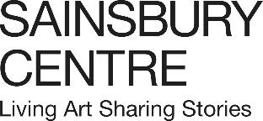

**Drugs, murder and the ocean - 2025 at the Sainsbury Centre**

The Sainsbury Centre will continue to ask important questions in 2025 through a wide array of interconnected exhibitions.

The international museum in Norwich will be tackling hard-hitting issues such as drugs in history and society, why people are driven to murder, and the survival of the sea, with over 10 exhibitions full of art, education and contemplation.

***Why Do We Take Drugs?***

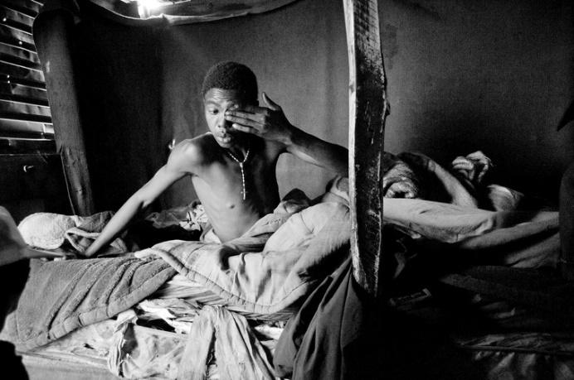**Season runs until 27 April 2025**

The year begins with the continuation of the acclaimed season *Why Do We Take Drugs?* From alcohol and caffeine to ayahuasca and heroin, art will continue to take visitors on a journey of investigation, exploring the world of global drug cultures from illegal to familiar across one museum landscape.

The six-month programme delves into drug cultures around the world and brings to life the highs and lows of drug taking in society.

Three shows continue to run until 2 February 2025. *Power Plants: Intoxicants, Stimulants and Narcotics* looks at how different cultures and art connect with the traditional consumption of tobacco and snuff, betel nut, kava, tea and palm wine, alongside an exploration of the sacred, hallucinogenic cactus, peyote. *Ayahuasca & Art of the Amazon* considers the impact of the mind-altering, psychotropic vine within Western Amazonian social life through Indigenous art. While *Ivan Morison: Towards the Weird Heart of Things* displays new four-meter-high sculptures in the Sculpture Park that change colour, transform, decay and compost over time in the artist’s response to the season.

A further two shows will run until 27 April 2025. *Heroin Falls* highlights the realities of heroin addiction through the eyes of two incredible photographers, Magnum photographer Lindokuhle Sobekwa (b.1995) and Scottish born, New York based photographer Graham MacIndoe (b.1963). While *Lindsey Mendick: Hot Mess* showcases new darkly comic and confessional works of Lindsey Mendick (b.1987), tackling social taboos and exposing the artist’s secret fears.

For another few months next year, visitors will be able to come to the Sainsbury Centre to explore both the organised and chaotic use of narcotics and intoxicants alongside the human stories, experiences and cultural impact of mind-altering substances.

*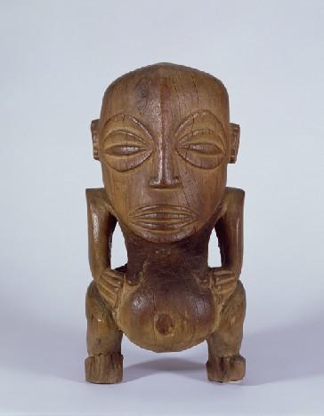****Can the Seas Survive Us?***

**15 March 2025 – 21 September 2025**

Three exhibitions will chart a course through the story of the oceans, and the dangerous future that they may be heading towards, featuring historical artworks, maps, atlases, archives, and contemporary art from across the globe.

*A World of Water* (15 March – 3 August) brings together a number of works by British and International artists from the last 250 years who have all offered a unique perspective of evolving marine ecosystems and oceanic environments. Featuring artworks by Josh Kline (b.1979), John Crome (1768–1821), Maggi Hambling (b.1945), George Vincent (1796–1832) and Hendricus Theodorus Wijdeveld (1885–1987), the exhibition will raise pivotal questions around how we can transform our interactions with the ocean, responding to climate change, coastal erosion and environmental degradation.

In Yuki Kihara’s solo show(15 March-3 August)*,* the Sainsbury Centre will host the UK premiere and further development of *Paradise Camp*, the celebrated work by Japanese and Samoan artist Yuki Kihara (b.1975). The work consists of 12 photographs that echo the works of Paul Gauguin (1848–1903) but challenge these past narratives, including casting Fa’afafine and Fa’atama models – a third gender community found in Sāmoan culture. Following its success at New Zealand Pavilion at the 2022 Venice Biennale, the work will be further developed following new research that reveals how evolutionary biologist Charles Darwin (1809–1882) shaped some of his findings to conform to the conservative values of the Victorian period.

Closing the series will be *Sea Inside* (7 June–21 September) which turns the oceanic gaze inward, investigating the physical, psychological and imaginary depths of humans with the ocean. Diving in shared watery origins, Indigenous lifeways and the contents we pluck out and display on land, the exhibition will feature a range of mixed media and experimental artworks by such as artists as Shuvinai Ashoona (b.1961), Marcus Coates (b.1968), Evan Ifekoya (b.1988) and Hiroshi Sugimoto (b.1948).

All three exhibitions will delve into humanity's deep relationship with the seas and act as a call to action – showing how coastal communities are bearing the brunt of human-caused climate change, the bodily and spiritual connections that could be lost, and how to continue with the waters that have shaped the very fabric of global society.

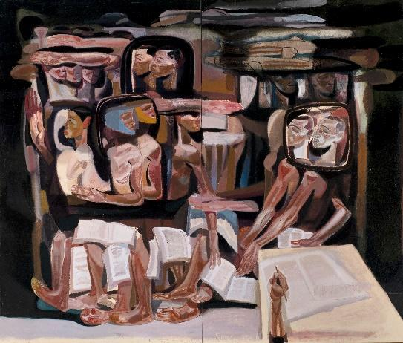  
***Can We Stop Killing Each Other?*  
*20* September 2025 – 3 May 2026**

The autumn season will wrestle with one of the darkest and deadliest aspects of humanity.

A series of exhibitions will explore the fundamental questions of why humans are led to kill and the culture that wrestles with this notion such as in art, film, TV and theatre.

Reflecting on the real material culture linked to particular case studies from the past and present, such as the Bengal Famine of 1943 and the Genocide against the Tutsi in Rwanda of 1994, the season will be a challenging but eye-opening consideration of some of the most horrifying events in human history.

A series of new paintings by Ethiopian artist Tesfaye Urgessa (b.1983) will also be unveiled, reflecting on the refugee crisis and created in dialogue with the Sainsbury Centre collection. Influenced by neo-expressionism and the London school, Urgessa’s figurative paintings explore the politics of race and identity.

**NOTES TO EDITORS**

[HIGH RESOLUTION IMAGES FOR MEDIA USE CAN BE DOWNLOADED HERE](https://www.dropbox.com/scl/fo/pquzr91rvh82zjghcfqlx/ALBrvMURwR2dDHDwPjXnGl8?rlkey=bgx08r1cu3yiio6pfc6kr4ce4&st=zycs2aj1&dl=0)

* Lindokuhle Sobekwa, *Thabang waking up in the early hours of the morning,* 2015, from the Nyaope project. Copyright: Lindokuhle Sobekwa / Magnum Photos
* *Male figure ('Fishermen's god'),* 1775 - 1825, wood. Copyright: Donated by Robert and Lisa Sainsbury, 1973
* Tesfaye Urgessa, *No country for young men, 31*, 2024, oil on canvas. Copyright: Tesfaye Urgessa. Courtesy of Cheng-Lan Art Foundation and Saatchi Yates

The **Sainsbury Centre** is a genre-defying art museum with world-class collections and a unique perspective on how art can foster cultural dialogue and exchange. It is one of the most important public university art galleries in Britain. Founded in 1973 at the University of East Anglia (UEA) with the support of one of the nation’s great philanthropic families, Sir Robert and Lady Sainsbury, who donated their extraordinary art collection which includes works dating from prehistory to the late 20th century from across the globe. A radical new building by Norman Foster was designed to house the collection and was his first public work. The Centre holds one of the most impressive art collections outside of the national institutions and is located on the edge UEA campus which is set in 350 acres of parkland. The Centre itself looks over 20 acres of our sculpture park threaded through meadow, forest and lake. It has the largest temperature-controlled gallery spaces in Eastern England and operates an only pay what you can ticketing system to help bring the best art in the world to anyone who wants to meet it.

Visit [www.sainsburycentre.ac.uk](https://d.docs.live.net/38500babd531eb7b/Documents/Work/BRERA/2024%20contract/Sainsbury%20Centre/2025/www.sainsburycentre.ac.uk) or call 01603 593199 (Monday–Friday, 10am–5pm)

Follow @sainsburycentre on Facebook, Twitter and Instagram

**FOR MORE INFORMATION, INTERVIEWS AND IMAGES**

Tracy Jones, Brera PR – tracy@brera-london.com / 01702 216658 / 07818 061503 / [www.brera-london.com](https://d.docs.live.net/38500babd531eb7b/Documents/Work/BRERA/2024%20contract/Sainsbury%20Centre/2025/www.brera-london.com)